Supplemental Material



Figure 1: Hand motion along each axis during the postural and kinetic tasks shown in Figure 2 in the manuscript, recorded from a patient with severe tremor. Tremor is especially visible in each direction in the postural task, and in the small ripples in the anterior-posterior direction in the kinetic task. Also visible in all three directions of the kinetic task are the large, voluntary back-and-forth movements of the hand. Hand motion was measured using a motion capture sensor (trakSTAR 3DGuidance by Ascension Technologies, Shelburne, VT) taped to the back of the hand.

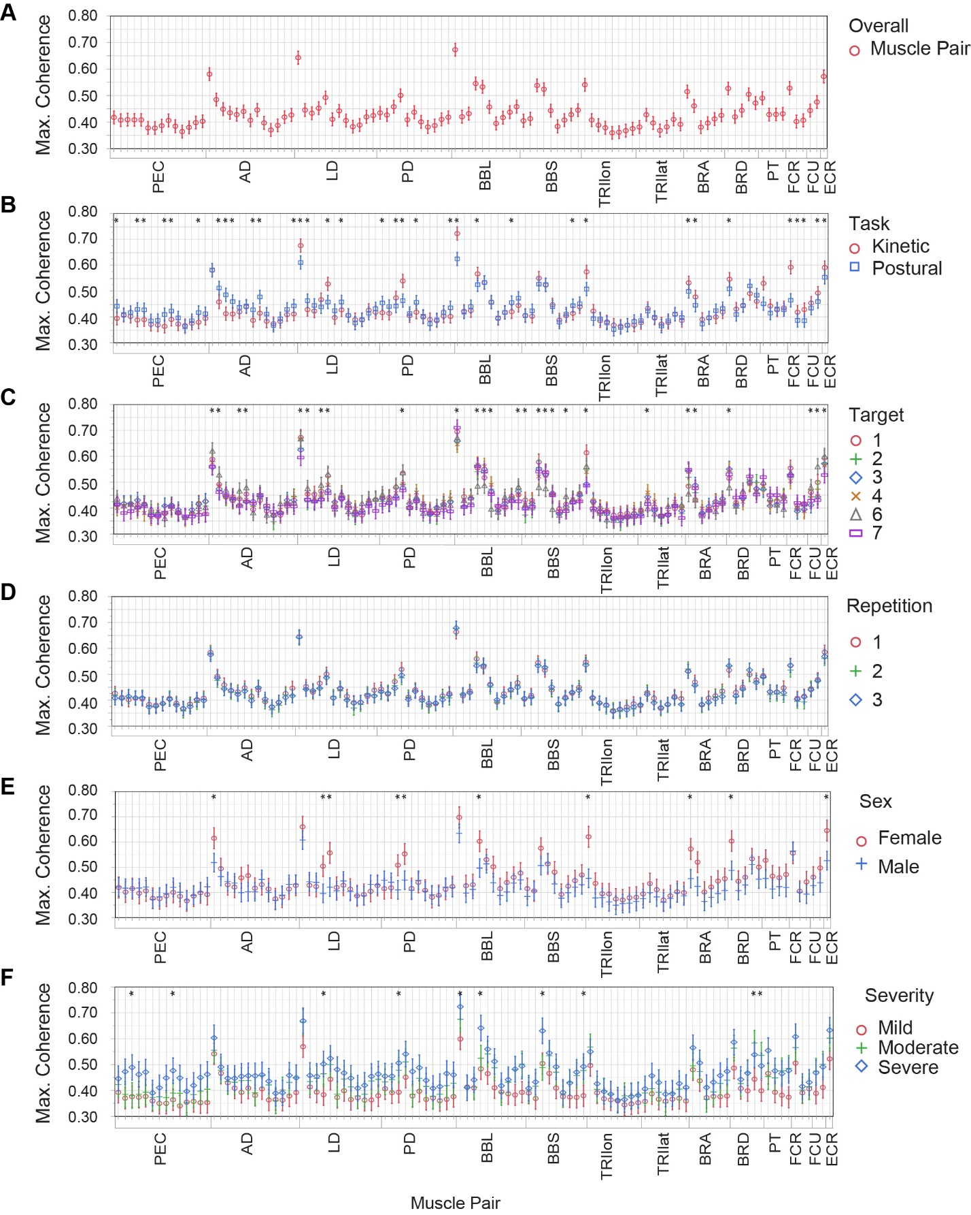

Figure 2: Graphical representation of the post-hoc analysis associated with the ANOVAs referenced in the manuscript. Maximum coherence in the tremor band of each muscle pair is shown, averaged across all trials (A) or separated by task (B), target (C), repetition (D), sex (E), and severity level (F). Significant differences within a muscle pair are noted with an asterisk. Plots of maximum coherence separated by disease duration and age of onset were similar to E and F, except with fewer significant differences (not shown). The ordering of muscle pairs is the same for each subplot: muscle pairs are grouped from proximal to distal (all pairs involving PEC, then all pairs involving AD, etc.; see caption of Figure 3 in the manuscript for definitions of abbreviations). For example, the first grid line shows coherence between PEC and AD, the second between PEC and LD, and the last between ECR and ECU. Markers and lines indicate mean ± 1 standard error, and asterisks indicate significant differences within a muscle pair.

Table : Muscle pairs that had a significant difference between tasks (postural or kinetic) or between targets (1-7 excluding 5).

|  |  |  |  |  |  |  |  |  |  |  |  |  |  |  |  |  |  |  |  |  |  |  |  |  |  |  |  |  |  |  |  |  |  |  |  |  |  |  |  |  |  |  |  |  |  |  |  |  |  |  |  |  |  |  |  |  |  |  |  |  |  |  |  |  |  |  |  |  |  |  |  |  |  |  |  |  |  |  |  |  |  |  |  |  |  |  |  |  |  |  |  |  |  |  |  |  |  |  |  |  |  |  |  |  |  |  |  |  |  |  |  |  |  |  |  |  |  |  |  |  |  |  |  |  |  |  |  |  |  |  |  |  |  |  |  |  |  |  |  |  |  |  |  |  |  |  |  |  |  |  |  |  |  |  |  |  |  |  |  |  |  |  |  |  |  |  |  |  |  |  |  |  |  |  |  |  |  |  |  |  |  |  |  |  |  |  |  |  |  |  |  |  |  |  |  |  |  |  |  |  |  |  |  |  |  |  |  |  |  |  |  |  |  |  |  |  |  |  |  |  |  |
| --- | --- | --- | --- | --- | --- | --- | --- | --- | --- | --- | --- | --- | --- | --- | --- | --- | --- | --- | --- | --- | --- | --- | --- | --- | --- | --- | --- | --- | --- | --- | --- | --- | --- | --- | --- | --- | --- | --- | --- | --- | --- | --- | --- | --- | --- | --- | --- | --- | --- | --- | --- | --- | --- | --- | --- | --- | --- | --- | --- | --- | --- | --- | --- | --- | --- | --- | --- | --- | --- | --- | --- | --- | --- | --- | --- | --- | --- | --- | --- | --- | --- | --- | --- | --- | --- | --- | --- | --- | --- | --- | --- | --- | --- | --- | --- | --- | --- | --- | --- | --- | --- | --- | --- | --- | --- | --- | --- | --- | --- | --- | --- | --- | --- | --- | --- | --- | --- | --- | --- | --- | --- | --- | --- | --- | --- | --- | --- | --- | --- | --- | --- | --- | --- | --- | --- | --- | --- | --- | --- | --- | --- | --- | --- | --- | --- | --- | --- | --- | --- | --- | --- | --- | --- | --- | --- | --- | --- | --- | --- | --- | --- | --- | --- | --- | --- | --- | --- | --- | --- | --- | --- | --- | --- | --- | --- | --- | --- | --- | --- | --- | --- | --- | --- | --- | --- | --- | --- | --- | --- | --- | --- | --- | --- | --- | --- | --- | --- | --- | --- | --- | --- | --- | --- | --- | --- | --- | --- | --- | --- | --- | --- | --- | --- | --- | --- | --- | --- | --- | --- | --- | --- |
| |  |  |  | | --- | --- | --- | | Muscle 1 | Muscle 2 | Higher Task | | AD | BBL | P | | AD | BBS | P | | AD | BRA | P | | AD | BRD | P | | AD | ECU | P | | AD | PD | P | | BBL | ECR | P | | BBS | ECR | P | | LD | BBL | P | | LD | BRD | P | | PD | BBL | P | | PD | BRD | P | | PD | ECU | P | | PEC | AD | P | | PEC | BBL | P | | PEC | BBS | P | | PEC | BRA | P | | PEC | BRD | P | | PEC | ECR | P | | BBL | BBS | K | | BBL | BRA | K | | BRA | BRD | K | | BRA | PT | K | | BRD | PT | K | | ECR | ECU | K | | FCR | ECR | K | | FCR | ECU | K | | FCR | FCU | K | | FCU | ECU | K | | LD | PD | K | | LD | TRIlat | K | | PD | TRIlat | K | | PD | TRIlon | K | | PT | FCR | K | | TRIlon | TRIlat | K | | |  |  |  |  | | --- | --- | --- | --- | | Muscle 1 | Muscle 2 | Higher Target(s) | Lower Target(s) | | AD | LD | 6,6 | 3,7 | | AD | PD | 6,6,6 | 2,3,7 | | AD | TRIlat | 6,6,6 | 2,3,7 | | AD | TRIlon | 6,6,6 | 3,4,7 | | BBL | BBS | 7,7,7 | 2,3,4 | | BBL | BRA | 1,2,3,4,7 | 6,6,6,6,6 | | BBL | BRD | 2,3,4,7 | 6,6,6,6 | | BBL | ECU | 6 | 7 | | BBL | PT | 1,2,3,4,7 | 6,6,6,6,6 | | BBS | BRA | 1,1,2,3,7, | 4,6,6,6,6 | | BBS | BRD | 1,2,3,4,7 | 6,6,6,6,6 | | BBS | FCU | 6 | 7 | | BBS | PT | 1,2,3,4,7 | 6,6,6,6,6 | | BBS | TRIlon | 1 | 2 | | BRA | BRD | 2,3,3,4,4,7,7 | 6,1,6,1,6,1,6 | | BRA | PT | 3,3 | 1,6 | | BRD | PT | 2,3,4,7 | 6,6,6,6 | | ECR | ECU | 1,6 | 7,7 | | FCU | ECR | 6,6 | 3,7 | | FCU | ECU | 1,1,1,6,6,6,6,6 | 3,4,7,1,2,3,4,7 | | LD | BBL | 6 | 2 | | LD | PD | 1,4,6 | 7,7,7 | | LD | TRIlat | 1,1,6,6 | 3,7,3,7 | | LD | TRIlon | 6,6 | 3,7 | | PD | TRIlat | 1,1,6,6 | 3,7,3,7 | | TRIlat | BRA | 4 | 6 | | TRIlon | TRIlat | 1,1,1,1,1,2,2,4,6,6 | 2,3,4,6,7,3,7,7,3,7 | |